**OOP**

**ANS-01:** No.

**Screenshot:**

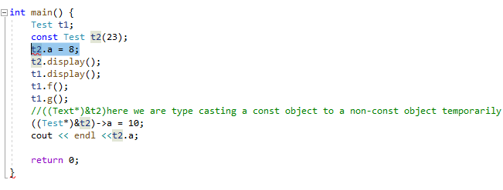

**ANS-02:** Yes

**Screenshot:**

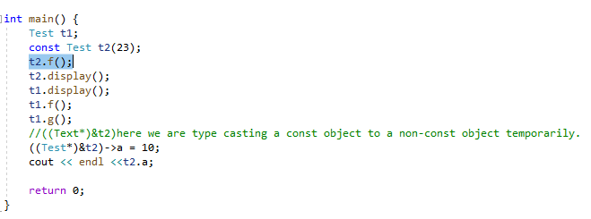

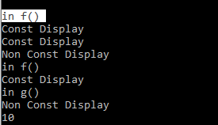

**ANS-03:** No.

**Screenshot:**

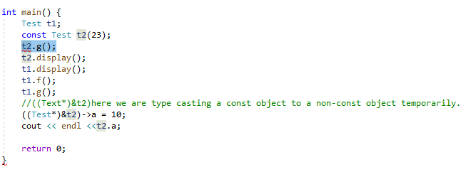

**ANS-04:** Yes.

**Screenshot:**

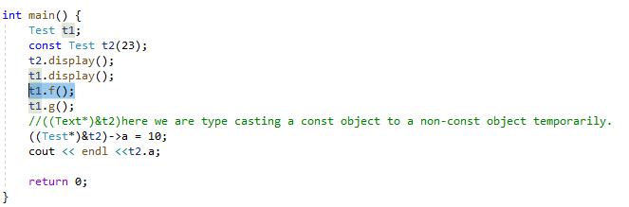

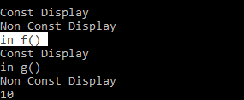

**ANS-05:** Yes.

**Screenshot:**

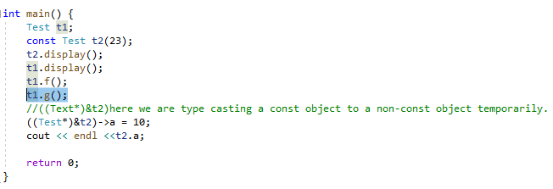

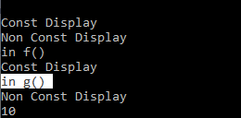

**ANS-06:** Yes.

**Screenshot:**

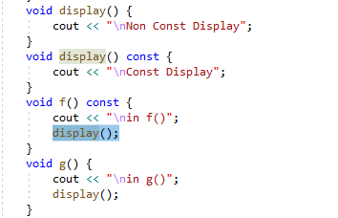

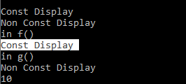

**ANS-07:** No.

**Screenshot:**

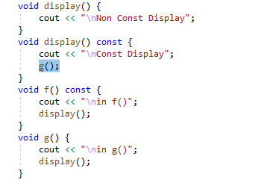

**ANS-08:** Yes.

**Screenshot:**

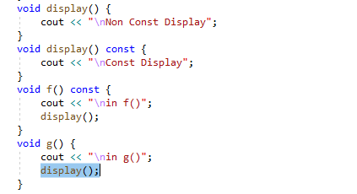

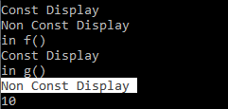

**ANS-09:** Yes.

**Screenshot:**

